
DVTK Design Specification
Session Library

1.0
2005-06-29

Table of Contents
1 Introduction 5
1.1 Purpose 5
1.2 Scope 5
1.3 Audience 5
1.4 Abbreviations and acronyms 5
1.5 References 5
1.6 History 5
2 Session concepts 7
2.1 Session 7
2.2 Session File 7
2.3 Session Parameters 7
2.3.1 SUT Test Session Properties 8
2.3.2 SUT ACSE Properties 8
2.3.3 DVT ACSE Properties 9
2.3.4 Socket Properties 9
2.3.5 Test Session Properties 10
2.3.6 Supported Transfer Syntaxes 11
2.3.7 Definitions 12
2.3.8 DICOMScripts 12
2.3.9 Results 12
2.3.10 DICOMScript Description Directory 12
2.4 Global design of Session library 13
3 Detail Design of Session Classes 14
3.1 Abstract Session Class 14
3.1.1 Serializing all the session parameters to a text file. 14
3.2 Base Session Class 15
3.2.1 Setting/getting the General session properties 16
3.2.2 Setting/getting the DVT session properties 16
3.2.3 Setting/getting the SUT session properties 17
3.2.4 Setting/getting the security properties of the session 17
3.2.5 Setting/getting the test properties of the session 18
3.2.6 Managing the Log Level flags 18
3.2.7 Managing the Definition Directory 19
3.2.8 Managing the Definition files 19
3.3 Detail Design of Abstract Map Class 19
3.3.1 Checking the mapped string 20
3.3.2 Checking the SOPClassUid 20
3.3.3 Getting the mapped string 20
3.4 Session File Class 20
3.4.1 Executing the Session 20
3.4.2 Saving the Session File 20
4 Detail Design of Emulator Session Class 21
4.1 Emulating as SCP 22
4.2 Emulating as Storage SCU 22
4.3 Emulating as verification SCU 22
4.4 Registering the emulator thread. 22
4.5 Un-registering the emulator thread. 22
4.6 Sending a Printer status event 23
4.7 Terminating the emulation connection 23
4.8 Starting the SCP emulator thread 23
5 Detail Design of Media Session Class 24
5.1 Serializing the media session to a text file 24
5.2 Beginning the media validation 24
5.3 Validating the media file 25
5.4 Terminating the media validation 25
5.5 Reading the media file 25
5.6 Writing the in memory object to file 25
5.7 Validating the Media File Dataset 25
5.8 Getting the directory records in a DICOMDIR file 25
6 Detail Design of Script Session Class 27
6.1 Executing a script 28
6.2 Parsing the script 28
6.3 Setting the callback for script execution 28
6.4 Re-setting the callback for script execution 28
6.5 Terminating the connection 28
6.6 Re-setting the association 28
6.7 Connecting on TCP IP 28
6.8 Listening on TCP IP 28
6.9 Importing the DICOM command 28
6.10 Importing the DICOM dataset 28
6.11 Setting the logging 28
6.12 Updating the defaults 28
6.13 Setting/Getting the confirmer 29
6.14 Sending the DICOM command 29
6.15 Receiving the DICOM command 29
6.16 Validating the DICOM command 29
6.17 Detail Design of Script Execution Context Class 30
6.17.1 Setting/Getting the Validation flag 30
6.17.2 Setting/Getting the StrictValidation flag 30
6.17.3 Setting/Getting the Define SQ Length flag 31
6.17.4 Setting/Getting the Add Group Length flag 31
6.17.5 Setting/Getting the Auto Type 2 Attributes flag 31
6.17.6 Setting/Getting the Populate With Attributes flag 31
6.17.7 Setting/Getting the Application Entity Name 31
6.17.8 Setting/Getting the Application Entity Version 31
7 BNF Grammar for the Session File Parameters 32

Introduction

Purpose
This document describes the global and detail design of the Session library. This is a living document and changes in the design should be laid down in this document. Especially the sections on detailed design of session classes may change during the project.

Scope
The concept of a test session applies to the User’s activities when performing a DICOM Validation test of a given SUT. The test session is a very useful container for all the configuration settings required to perform the tests on the SUT. This library defines classes used to describe the session file & its parameters used by the DICOM Validation Tool.

Audience
This document is intended for all the implementers in the DVT project. The reader is assumed to have basic DICOM knowledge.

Abbreviations and acronyms
Abbreviation / acronym | Description
AE | Application Entity
Definition File | File containing the DICOM SOP Class description(s).
DVT | DICOM Validation Tool.
Session File | File containing the test session parameters.
User | Person who is implementing the Definition library.
SUT | System Under Test - Product being tested by DVT for conformance to DICOM.
VR | Value Representation

References
Reference | Title | Author/Publisher | Document number
SESSION | Test Session File Specification | R. Busbridge | XZS 980-000119.00
SCRIPT | DICOMScript Language Specification | R. Busbridge | XZS 980-000118.00
DESIGNSPEC |  | R. Busbridge  M. van Minderhout | XZS 980-000183.01
PATTERNS | Design Patterns | E. Gamma et al. | ISBN 0201633612
DCM | DICOM standard 2004 | NEMA | PS 3.0-2004

History
Version | Date | Author | Description
0.1 | 29 May 2005 | Piyush Bhageriya  Manisha Singla | Initial version
1.0 | 29 June 2005 | Piyush Bhageriya  Manisha Singla | Update for OpenSource release

Session concepts
The concept of a Session is used as a framework for assembling the individual test scenarios into a meaningful set. The test session is a very useful container for all the configuration settings required to perform the tests on the SUT.
DVT will have the ability to support multiple concurrent test sessions.

Session
The Session is used to:
- Identify the product being tested.
- Identify the person conducting the test.
- Time-stamp of the tests.
- Identify the tests performed.
- Identify the Validation Tool version used to perform the tests.

Test Scenarios
Within the Test Session, various scripts, emulators or media files can be used to perform the Test Scenarios.

Test Results
DVT stores the results of each test (either by DICOMScript, DICOMSuperScript, VBScript, Media Validation or Emulation) in a XML file. Two types of results files can be generated:
Detailed Results File – the full validation results are stored in the detailed results file.
Summary Results File – a summary of the validation results, showing errors and warnings, are stored in the summary results.

Session File
The concept of session applies to the User’s activities when performing a DICOM Validation test of a given SUT.

Three different test sessions are foreseen:
- Scripting (script based) test session
Test session is based on the use of scripts i.e. DICOM Scripts, VB Scripts
- Emulator (SCU or SCP) test session
Test session is based on the use of the in-built emulators.
- Media test session
Test session is based on the media validation.
The test session parameters may vary depending on the type of test session.

Session Parameters
The session can contain the following parameters:

- SUT Test Session Properties
- SUT ACSE Properties
- DVT ACSE Properties
- Socket Properties
- Test Session Properties
- Supported Transfer Syntaxes
- Definitions
- DICOMScripts
- Results
- DICOMScript Description Directory

A subset of the above parameters is found in the scripting, emulator and media Test Session files.

SUT Test Session Properties
The SUT Test Session Properties are used to detail the Session specific properties and are:

- Session Type: It defines the type of session being one of script, emulator or media.
- Session File version: It defines the version number of the session file.
- Session Title: It is a free text string, which can be used for a logical description of the session.
- Session ID: It is a number, ranging from 1 to 9999, used to identify the test session. The SESSION-ID is also used by DVT when generating the Test Results files.
- Manufacturer: It is the name of the company producing the Product being tested.
- Model Name: It is the Manufacturer’s name for the Product being tested.
- Application Entity Name: It is the name of the application (within the Product) being tested. The default value is “DICOM”.
- Application Entity Version: It is the version of the application (within the Product) being tested. The default value is “3.0”.
- Software versions: It is the Manufacturer’s description of the software version(s) used by the Product being tested.
- Tested by: It is the name of the person(s) performing the validation test.
- Date: This is the date on which the validation test was performed. It must be expressed in YYYYMMDD format.

SUT ACSE Properties
The SUT ACSE Properties define the SUT parameters used when establishing an Association using the A-ASSOCIATE-RQ PDU and the A-ASSOCIATE-AC PDU and are:

- SUT Role: It is the setting of requestor indicates that the SUT will take the role of Association Requestor and DVT the role of Association Acceptor in this session.
The setting of acceptor indicates that the SUT will take the role of Association Acceptor and DVT the role of Association Requestor in this session.

- SUT AE Title: It is the AE Title of the SUT in the test.
- SUT Maximum Length Received: It is the maximum length of message fragment (P-DATA-TF PDU) that the SUT can receive from DVT. DICOM messages are split into P-DATA-TF PDU fragments - e.g., C-STORE-RQ of a modality image.
- SUT Implementation Class UID: It is the DICOM UID assigned by the Manufacturer to the SUT implementation to identify it internally. DVT checks that the value sent by the SUT matches the value given here.
- SUT Implementation Version Name: It is the version name given by the Manufacturer to the SUT implementation to identify it internally. DVT checks that the value sent by the SUT matches the values given here.

DVT ACSE Properties
The DVT ACSE Properties define the DVT parameters used when establishing an Association using the A-ASSOCIATE-RQ PDU and the A-ASSOCIATE-AC PDU and are:

- DVT AE Title: It is the AE Title of DVT in the test.
- DVT Maximum Length Received: It is the maximum length of message fragment (P-DATA-TF PDU) that DVT can receive from the SUT. DICOM messages are split into P-DATA-TF PDU fragments - e.g., C-STORE-RQ of a modality image.
- DVT Implementation Class UID: It is the DICOM UID assigned to DVT.
- DVT Implementation Version Name: It is the version name assigned to DVT.

Socket Properties
The Socket Properties define the TCP/IP and the security properties and are:

- SUT Hostname: It is the name that DVT should use when making a connection to the SUT. It is best to enter the Internet Address of the SUT (in dot notation).
- SUT Port: It is the port number that DVT should use when making a connection to the SUT.
- DVT Port: It is the port that the SUT should use when making a connection to DVT.
- DVT Socket Timeout: It is the time-out in seconds used by DVT to wait for incoming data over a connected socket.
- Use Secure Sockets: It is a Boolean flag used to indicate whether the DICOM communication should be made over a secure socket (set true) or non-secure socket (set false).
- TLS Version: It indicates whether TLS V1.0 or SSL V3.0 security should be used. Only applicable when USE-SECURE-SOCKETS is true.
- Check Remote Certificate: It is a Boolean flag used to indicate whether the X.509 certificate received from the SUT should be validated (set true) or not (set false) as part of the SSL Handshake. Only applicable when USE-SECURE-SOCKETS is true.
- Cipher List: It defines the cipher list used to establish the secure connection during the SSL Handshake. The value of the string is a concatenation of the possible settings for the SSL Authentication, Key Exchange, Data Integrity and Encryption parameters. Only applicable when USE-SECURE-SOCKETS is true.
- Cache TLS Sessions: It is a Boolean flag used to indicate whether the secure session established during the SSL Handshake should be cached for future use (set true) or not (set false). If the parameter is set true and the cache is still valid (see TLS-CACHE-TIMEOUT) then the SSL Handshake for any new connection is much shorter and the secure connection established more quickly. If the session cache is no longer valid then the full SSL Handshake is required to establish a new secure connection. Only applicable when USE-SECURE-SOCKETS is true.
- TLS Cache Timeout: It defines the time in seconds for which the secure session cache is valid. Only applicable when USE-SECURE-SOCKETS is true.
- Credentials Filename: It defines the full pathname to a file containing the X.509 Private Key and Public Certificate that DVT should use when trying to establish a secure connection. Only applicable when USE-SECURE-SOCKETS is true.
- Certificate Filename: It defines the full pathname to a file containing the X.509 Trusted Certificates of all the SUTs with which DVT will try to establish a secure connection. Only applicable when USE-SECURE-SOCKETS is true.

Test Session Properties
Test Session Properties are used to define switch settings for DVT. Some of these properties are flags indicating the level of detail in which to display the test results. The Test Properties are:

- LOG-ERROR flag, when enabled (set true), causes any Errors detected by DVT to be logged.
- LOG-WARNING flag, when enabled (set true), causes any Warnings detected by DVT to be logged.
- LOG-INFO flag, when enabled (set true), causes any Information produced by DVT to be logged.
- LOG-RELATION flag, when enabled (set true), causes any DICOM Object Relationship information produced by DVT to be logged.
- LOG-DEBUG flag, when enabled (set true), causes any debug information to be logged.
- LOG-DULP-STATE flag, when enabled (set true), causes the event and state change information in the DULP Finite State Machine to be logged.
- LOG-SCP-THREAD flag, when enabled (set true), causes the SCP threads, created to handle the SCP emulations, to log data as described by the other LOG-xxx flags above.
- PDU-DUMP flag, when enabled, causes the sent / received messages to be displayed in BYTE format at the socket level, i.e., socket read & write. NOTE: Only, the first 1024 bytes of every P-DATA-TF PDU is displayed.
- LABEL-DUMP flag, when enabled, causes the final values of the Labeled attributes to be displayed to the user at the end of the DICOM(Super)Script.
- STORAGE-MODE flag can take one of the following values:
- as-media – Any received storage IOD will be stored in the DICOM Media Storage File format (i.e., including the File Prefix, DICOM Preamble and File Meta Information) with a file extension .DCM.
- as-dataset – Any received storage IOD will be stored in a “raw” format with only the Dataset being saved. The file extension is .RAW.
- no-storage – Do not store any received storage IOD.
- CONTINUE-ON-ERROR flag when enabled (set true), is used by DVT when executing DICOMSuperScripts, to contiue the execution of the included DICOMScipts even if one of the DICOMScripts fails. When this flag is disabled DVT will stop DICOMSuperScript execution after the first occurance of an error in a DICOMScript.
- STRICT-VALIDATION flag, when enabled (set true), causes DVT to perform a strict check between the received ACSE and DICOM messages and those programmed (expected) in the DICOMScripts. It any parameter of the received message does not match that programmed, then DVT reports a FAILED validation and aborts further DICOMScript interpretation.
When this flag is disabled (set false), then DVT will warn the User when a mismatch occurs between received and programmed values. DVT will continue interpreting the DICOMScript.
This feature is particularly useful when the User wishes to test a specific (range of) SOP Class(es). Any additional SOP Classes proposed by the Product will be automatically rejected by DVT, allowing the User to concentrate on the SOP Class(es) of interest to the Test Scenario.
- AUTO-TYPE-2-ATTRIBUTES flag, when enabled (set true), causes DVT to add any Type 2 Attributes (with a zero-length) to the DICOMScript defined Dataset before sending it to the Product. DVT consults to Definition File corresponding to the Dataset in order to check the Dataset “completeness” before sending it to the Product. This feature ensures that the output produced by DVT conforms to the Dataset definition without the User having to explicitly set any zero-length Attributes.
- AUTO-CREATE-DIRECTORY flag, when enabled (set true), causes DVT to create any missing directories when handling the WRITE command to ensure that the pathname defined by the WRITE command is available before the file is written. This can be disabled to allow the user to generate the directories manually thus ensuring the intended directory structure is used.
- DEFINE-SQ-LENGTH flag, when enabled (set true), is used to make DVT encode explicit length Sequences when sending messages. Explicit lengths are computed for both the Sequence and each Item present within the Sequence. By default DVT uses the undefined length encoding.
- ADD-GROUP-LENGTH flag, when enabled (set true), is used to have DVT add Group Length attributes to all Groups found in each message sent. By default DVT does not encode Group Length attributes (except for the Command Group Length).
- DETAILED-VALIDATION-RESULTS flag, when enabled (set true), is used to have DVT produce detailed validation results, which include all the attributes of all the modules present in any dataset being validated. This property can be used together with the SUMMARY-VALIDATION-RESULTS to get both detail and summary results during a test.
- SUMMARY-VALIDATION-RESULTS flag, when enabled (set true), is used to have DVT produce summary validation results. The summary only shows the attributes (in their modules), which have validation errors. This property can be used together with the DETAILED-VALIDATION-RESULTS to get both detail and summary results during a test.
- INCLUDE-TYPE-3-NOTPRESENT-INRESULTS flag, when enabled (set true), is used to have DVT include all Type 3 attributes in the detailed results even if these attributes are not present in the dataset being validated. When this property is disabled (set false) the detailed results produced contain only the attributes present in the dataset being validated.

Supported Transfer Syntaxes
This parameter is used to define a Transfer Syntax that DVT will accept when working in an SCP emulation mode. It is repeated for each Transfer Syntax supported by DVT.

Definitions
The Session File can contain a DEFINITION-ROOT <pathname> parameter, which is used to prefix the definition file names in order to define the full definition pathname.
The Session File can also contain an optional list of Definition Files. DVT loads this list of Definition Files when the Session File is opened.

NOTE: DVT will automatically correct the pathname separator (slash or backslash) for the platform on which it is running. The User can use either type of separator.

DICOMScripts
The Session File can contain a DICOMSCRIPT-ROOT <pathname> parameter which is used to prefix the DICOMScript names in order to define the full DICOMScript pathname.
The Session File can also contain an optional list of DICOMScripts. DVT will execute this list of DICOMScripts when the Session File is opened.

NOTE: DVT will automatically correct the pathname separator (slash or backslash) for the platform on which it is running. The User can use either type of separator.

Results
The Session File can contain a RESULTS-ROOT <pathname> parameter, which is used to prefix the Result File names in order to define the full Result File pathname.

DICOMScript Description Directory
The DESCRIPTION-DIRECTORY property defines the directory in which HTML descriptions of the DICOMScripts can be found. The HTML description file has the same name as the DICOMScript but a HTML extension instead of .DS or .DSS.
The HTML description file can be used to provide a full description of the test scenario covered by the DICOMScript including graphics.

Global design of Session library
The Session files are ASCII text files and can be modified by user. The Session File format can formally be described in [SESSION] Backus-Naur Form (BNF). The Lex/yacc parser should be written for parsing the session files.

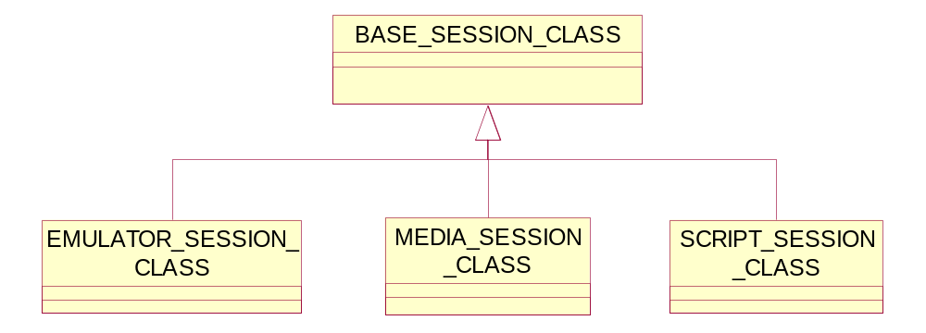
Figure 1 Relationship diagram for session classes

DVT supports three different Session types:
- Emulator (SCU or SCP).
- Script (script based).
- Media.

The session parameters may vary depending on the type of session.
The Base session class used to get/set the session parameters obtained after parsing the session files. Depending on the type of session, the parameters may vary. Each session type is represented by a class derived from base session class.

Detail Design of Session Classes

Abstract Session Class
The Abstract Test Session Class is used purely to determine the actual session file type.

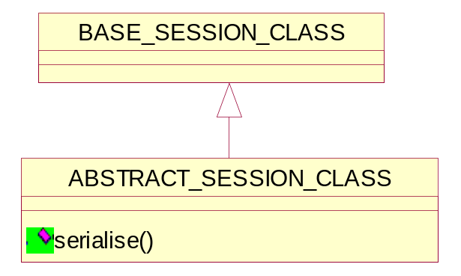
Figure 2 Class diagram of Abstract Session

Serializing all the session parameters to a text file.
bool serialise(FILE*);
This method will be implemented by derived session classes.

Return value | Explanation
true | The operation is successful i.e if the session is written successfully to the file.
false | The operation is failed.

Base Session Class
The Base Session class manages all session parameters. This class is the base class of all types of session class.

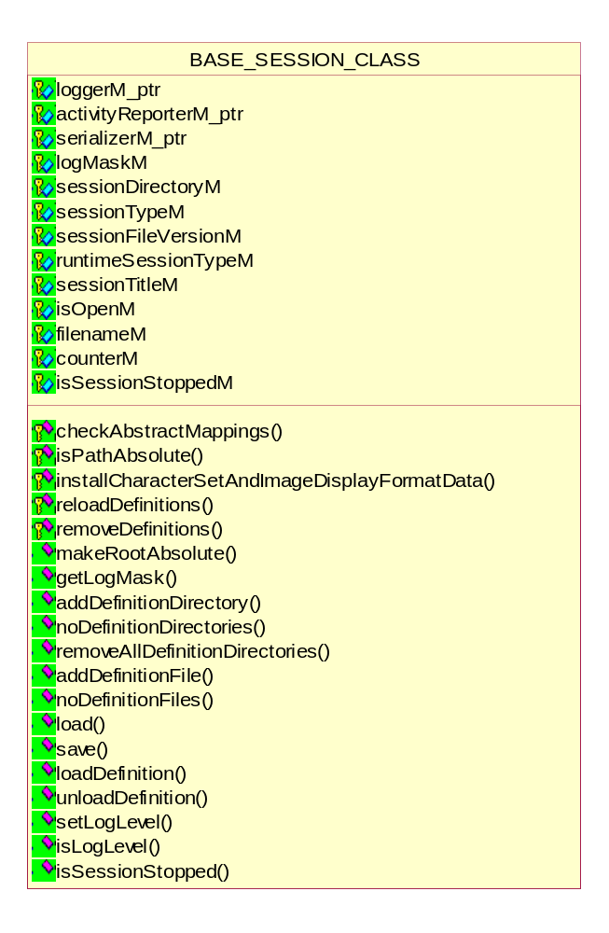
Figure 3 Class diagram of Base Session

Note: In the class diagram all virtual get/set functions are not mentioned.
It is a base session class , from which various test session classes are derived. It mainly consists of virtual get/set functions to set the various session properties.

Setting/getting the General session properties
The following methods are used to set/get the general session properties ref 2.3. The derived session classes provide specific implementation for a particular session type.

void setSessionType(SESSION_TYPE_ENUM sessionType);
void setSessionTitle(char *sessionTitle_ptr);
void setSessionId(int sessionId);
void setModelName(char *modelName_ptr);
void setSoftwareVersions(char *softwareVersions_ptr);
void setTestedBy(char *testedBy_ptr);
void setDate(char *date_ptr);
void setDetailedValidationResults(bool flag);
void setSummaryValidationResults(bool flag);
void setIncludeType3NotPresentInResults(bool flag);
SESSION_TYPE_ENUM getSessionType();
SESSION_TYPE_ENUM getRuntimeSessionType();
const char *getSessionTitle();
int getSessionId();
const char *getManufacturer();
const char *getModelName();
const char *getSoftwareVersions();
const char *getApplicationEntityName();
const char *getApplicationEntityVersion();
const char *getTestedBy();
const char *getDate();
bool getDetailedValidationResults();
bool getSummaryValidationResults();
bool getIncludeType3NotPresentInResults();
void setFileName (string fileName);
virtual void setStorageMode(STORAGE_MODE_ENUM storageMode);
void setDefinitionFileRoot(char*);
const char *getDefinitionFileRoot();
void addDefinitionFile(DEFINITION_FILE_CLASS *defFile_ptr);
UINT noDefinitionFiles();
DEFINITION_FILE_CLASS *getDefinitionFile(UINT);
const char *getDefinitionFilename(UINT);
void setResultsRoot(char*);
const char *getResultsRoot();
void setDescriptionDirectory(string);
string getDescriptionDirectory();
void setSystemAppDomainBaseDirectory(string);
string getSystemAppDomainBaseDirectory();

Setting/getting the DVT session properties
The following methods are used to set/get the DVT properties ref 2.3.3. The derived session classes provide specific implementation for a particular session type.

virtual void setDvtAeTitle(char*);
virtual const char *getDvtAeTitle();
virtual void setDvtMaximumLengthReceived(int);
virtual UINT32 getDvtMaximumLengthReceived();
virtual void setDvtImplementationClassUid(char*);
virtual const char *getDvtImplementationClassUid();
virtual void setDvtImplementationVersionName(char*);
virtual const char *getDvtImplementationVersionName();
virtual void setDvtPort(UINT16);
virtual UINT16 getDvtPort();
virtual void setDvtSocketTimeout(int);
virtual int getDvtSocketTimeout();

Setting/getting the SUT session properties
The following methods are used to set/get the SUT properties ref 2.3.1. The derived session classes provide specific implementation for a particular session type.

virtual void setSutAeTitle(char*);
virtual const char *getSutAeTitle();
virtual void setSutMaximumLengthReceived(int);
virtual UINT32 getSutMaximumLengthReceived();
virtual void setSutImplementationClassUid(char*);
virtual const char *getSutImplementationClassUid();
virtual void setSutImplementationVersionName(char*);
virtual const char *getSutImplementationVersionName();
virtual void setSutHostname(char*);
virtual const char *getSutHostname();
virtual void setSutPort(UINT16);
virtual UINT16 getSutPort();
virtual void setSutRole(UP_ENUM);
virtual UP_ENUM getSutRole();

Setting/getting the security properties of the session
The following methods are used to set/get the security properties ref 2.3.4. The derived session classes provide specific implementation for a particular session type.

virtual void setTlsPassword(const char*);
virtual bool isTlsPasswordValid(bool& unencryptedKeyFound);
virtual void setTlsVersion(const char*);
virtual void setCheckRemoteCertificate(bool);
virtual void setCipherList(const char*);
virtual void setCacheTlsSessions(bool);
virtual void setTlsCacheTimeout(int);
virtual void setCredentialsFilename(const char*);
virtual void setCertificateFilename(const char*);
virtual void setSocketParametersChanged(bool);
virtual bool getUseSecureSockets();
virtual const char *getTlsPassword();
virtual const char *getTlsVersion();
virtual bool getCheckRemoteCertificate();
virtual const char *getCipherList();
virtual bool getCacheTlsSessions();
virtual int getTlsCacheTimeout();
virtual string getCredentialsFilename();
virtual string getCertificateFilename();

Setting/getting the test properties of the session
The following methods are used to set/get the test session properties ref 2.3.5. The derived session classes provide specific implementation for a particular session type.

virtual void setApplicationEntityName();
virtual void setApplicationEntityVersion();
virtual void setLogScpThread(bool);
virtual void setStrictValidation(bool);
virtual void setAutoType2Attributes(bool);
virtual void setAutoCreateDirectory(bool);
virtual void setDefineSqLength(bool);
virtual void setAddGroupLength(bool);
virtual void setContinueOnError(bool);
virtual void deleteSupportedTransferSyntaxes();
virtual void addSupportedTransferSyntax(char*);
virtual bool getLogScpThread();
virtual bool getStrictValidation();
virtual bool getAutoType2Attributes();
virtual bool getAutoCreateDirectory();
virtual bool getDefineSqLength();
virtual bool getAddGroupLength();
virtual bool getContinueOnError();
virtual int noSupportedTransferSyntaxes();
virtual const char *getSupportedTransferSyntax(int);
virtual void setDicomScriptRoot();
virtual const char *getDicomScriptRoot();
virtual void addDicomScript(DICOM_SCRIPT_CLASS*);
virtual bool begin(bool&);
virtual void end();
virtual bool executeScript(string);
virtual bool parseScript(string);
virtual void setScpEmulatorType(SCP_EMULATOR_ENUM);
virtual SCP_EMULATOR_ENUM getScpEmulatorType();
virtual void setScuEmulatorType(SCU_EMULATOR_ENUM);
virtual SCU_EMULATOR_ENUM getScuEmulatorType();
virtual bool emulateSCP();
virtual bool sendStatusEvent();
virtual bool terminateConnection();
virtual void resetAssociation();
virtual void setScriptDoneCallBack(void(*)(void*), void*);
virtual void resetScriptDoneCallBack(void);
virtual bool beginMediaValidation();
virtual bool validateMediaFile(string);
virtual bool endMediaValidation();
virtual void setLogger();
virtual void setActivityReporter(BASE_ACTIVITY_REPORTER*);
virtual void setSerializer(BASE_SERIALIZER*);

Managing the Log Level flags
- Setting/Getting the Log Level
LOG_CLASS *getLogger();
void enableLogger();
void disableLogger();
void setLogLevel(bool, UINT32);
bool isLogLevel(UINT32);
These are the methods to get/set and check the Log Level ref 2.3.5. The Log levels are flags indicating the level of detail in which to display the test results.

Managing the Definition Directory
- Setting/Getting the definition file root
UINT noDefinitionDirectories();
string getDefinitionDirectory(UINT);
void setDefinitionFileRoot(char*);
void removeAllDefinitionDirectories();
These are the methods to get/set and number of the definition directories ref 2.3.7.

Managing the Definition files
- Adding/checking Definition Files
void addDefinitionFile(DEFINITION_FILE_CLASS *defFile_ptr);
UINT noDefinitionFiles();
DEFINITION_FILE_CLASS *getDefinitionFile(UINT);
const char *getDefinitionFilename(UINT);

- Loading/Unloading the Definition File
bool loadDefinition(string);
bool unloadDefinition(string);
These are the methods to get/set and number of the definition directories ref 2.3.7.

Detail Design of Abstract Map Class
The Abstract Map class used for SOP class UID name mapping.

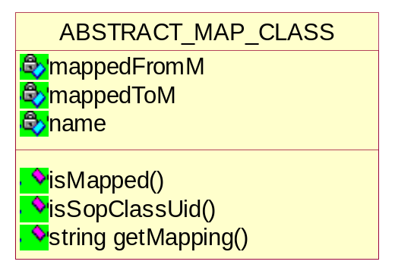
Figure 4 Class diagram of Abstract map

Checking the mapped string
bool isMapped(const string);
This is the method to check if the string from matches that given string.

Checking the SOPClassUid
bool isSopClassUid(const string);

Getting the mapped string
string getMapping();

Session File Class
This class represents the session file itself. It derived from BASE_FILE_CLASS and implements the basic definition file operation e.g. saving of a particular session file.

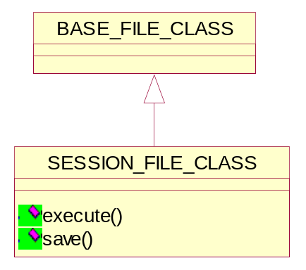
Figure 5 Class diagram of Session File

Executing the Session
bool execute();
This method is used to instantiate the execution of a session.

Saving the Session File
bool save();
It is used to save the changes made in a session file.

Detail Design of Emulator Session Class
An emulator session is used when DVT should act as an SCU or SCP emulator. DVT currently has emulator support as follows:
- Verification SCU
- Verification SCP
- Storage SCU
- Storage SCP (including Storage Commitment SCP)
- Print SCP
The DVT configuration parameters used during an emulator session are stored in an emulator Session File.
The Emulator Session class manages all types of emulators. This class manages all the session parameters related to emulator.

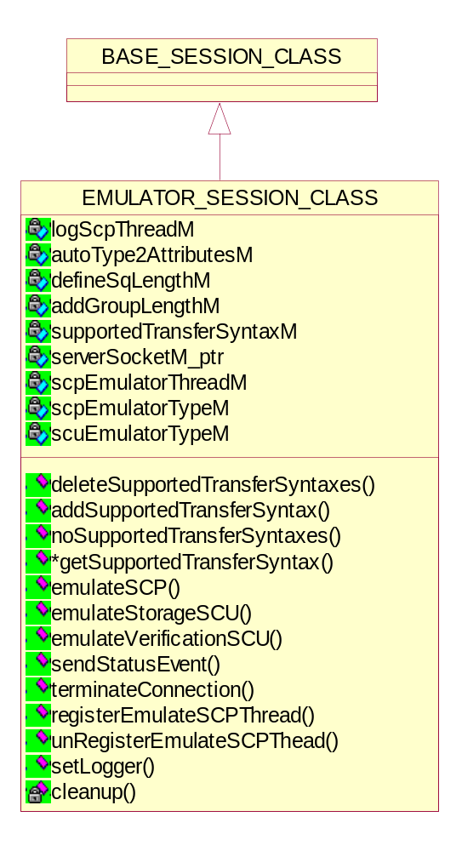
Figure 6 Class diagram of Emulator Session

Note: All the get/set properties are not shown in the Class Diagram and those can be referred from the Session Class ref 3.

Emulating as SCP
bool emulateSCP();

Return value | Explanation
true | The operations is successful i.e the emulator emulates as Storage/Print SCP Emulator.
false | The operations is failed i.e the session is stopping, return instead of creating a new child thread.
This method supports multiple instances of emulator by spawning a new thread to handle each connection and also
- Instantiate a storage emulator
- Instantiate a print emulator

Emulating as Storage SCU
bool emulateStorageSCU(
vector<string>* filenames,
UINT options, UINT nr_repetitions = 1);

Return value | Explanation
true | The operations is successful i.e the emulator emulates as Storage SCU Emulator.
false | The operations is failed i.e the execution is stopped.
This method instantiates a storage emulator.

Emulating as verification SCU
bool emulateVerificationSCU();

Return value | Explanation
true | The operations is successful i.e the emulator emulates as Verification SCU.
false | The operations is failed i.e the execution is stopped.

Registering the emulator thread.
void registerEmulateSCPThread(BASE_SCP_EMULATOR_CLASS*);
This method is used to register an emulation thread so that it can be halted during execution if necessary – terminate connection option.

Un-registering the emulator thread.
void unRegisterEmulateSCPThead(BASE_SCP_EMULATOR_CLASS*);
This method un-registers the emulation thread on normal thread completion.

Sending a Printer status event
bool sendStatusEvent();

Return value | Explanation
true | The operation is successful.
false | The operation is failed.

Terminating the emulation connection
bool terminateConnection();

Return value | Explanation
true | The operation is successful i.e the emulator has stopped.
false | The operation is failed.

Starting the SCP emulator thread
UINT ScpEmulatorThread(void *param_ptr);

Return value | Explanation
true | The operation is successful i.e the emulator has stopped.
false | The operation is failed.
This function acts as SCP emulator thread. This is started when a thread is spawned to handle a new SCP association.

Detail Design of Media Session Class
Media sessions are used when media files (DICOMDIR, DCM, Part-10 files) are being validated. When validating a DICOMDIR file any referenced files found in the DICOMDIR will also be validated.
The DVT configuration parameters used during a media session are stored in a media Session File.
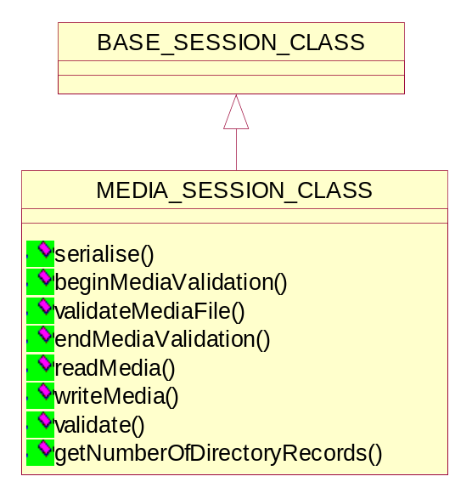
Figure 7 Class diagram of Media Session

Serializing the media session to a text file
bool serialise(FILE*);

Return value | Explanation
true | The operation is successful i.e if the media session is written successfully to the file.
false | The operation is failed.

Beginning the media validation
bool beginMediaValidation();

Return value | Explanation
true | The operation is successful i.e if the media validation is started.
false | The operation is failed.

Validating the media file
bool validateMediaFile(string);

Return value | Explanation
true | The operation is successful i.e if the media validation is successful.
false | The operation is failed.

Terminating the media validation
bool endMediaValidation();

Return value | Explanation
true | The operation is successful i.e if the media validation is terminated.
false | The operation is failed.

Reading the media file
FILE_DATASET_CLASS* readMedia(string, bool useSessionStorageMode, bool logIt);
It reads the media file to in memory FILE_DATASET_CLASS object. It returns NULL on failure to load media.

Writing the in memory object to file
bool writeMedia(FILE_DATASET_CLASS*);

Return value | Explanation
true | The operation is successful.
false | The operation is failed.
It writes the in memory FILE_DATASET_CLASS object to file.

Validating the Media File Dataset
bool validate(FILE_DATASET_CLASS*, VALIDATION_CONTROL_FLAG_ENUM);

Return value | Explanation
true | The operation is successful i.e if the validation is completed successfully.
false | The operation is failed.

Getting the directory records in a DICOMDIR file
int getNumberOfDirectoryRecords(string);
This method returns the number of records in a DICOMDIR. If the given file is not a DICOMDIR it return 0 records.

Detail Design of Script Session Class
A script session is used when DVT is used to execute DICOM(Super)Scripts and VBScripts. DVT currently has scripting support for:
- Network SCU and SCP message exchange – DVT can act as either SCU or SCP in the communication.
- Media file creation (FSC) – DICOM(Super)Scripts can be used to create media files on known content. These can be used to test media readers (FSR).

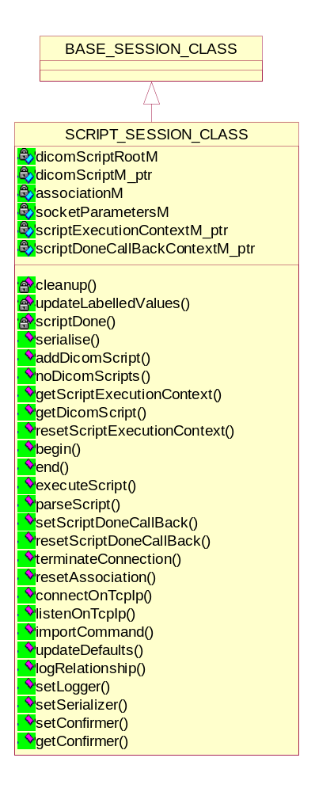
Figure 8 Class diagram of Script Session
The DVT configuration parameters used during a script session are stored in a script Session File.

Executing a script
bool executeScript(string);

Parsing the script
bool parseScript(string);

Setting the callback for script execution
void setScriptDoneCallBack(void (*)(void*), void*);

Re-setting the callback for script execution
void resetScriptDoneCallBack(void);

Terminating the connection
bool terminateConnection();

Re-setting the association
void resetAssociation();

Connecting on TCP IP
bool connectOnTcpIp();

Listening on TCP IP
bool listenOnTcpIp();

Importing the DICOM command
bool importCommand(DIMSE_CMD_ENUM, string);

Importing the DICOM dataset
bool importCommandDataset(DIMSE_CMD_ENUM, string, string, string);

Setting the logging
void logRelationship();
void setLogger(LOG_CLASS*);

Updating the defaults
void updateDefaults(ASSOCIATE_RQ_CLASS*);

Setting/Getting the confirmer
void setConfirmer(BASE_CONFIRMER *);
BASE_CONFIRMER *getConfirmer();

Sending the DICOM command
bool send(ASSOCIATE_RQ_CLASS*, string);
bool send(ASSOCIATE_AC_CLASS*, string);
bool send(ASSOCIATE_RJ_CLASS*, string);
bool send(RELEASE_RQ_CLASS*, string);
bool send(RELEASE_RP_CLASS*, string);
bool send(ABORT_RQ_CLASS*, string);
bool send(UNKNOWN_PDU_CLASS*, string);
bool send(DCM_COMMAND_CLASS*);
bool send(DCM_COMMAND_CLASS*, DCM_DATASET_CLASS*);

Receiving the DICOM command
bool receive(ASSOCIATE_RQ_CLASS*, string);
bool receive(ASSOCIATE_AC_CLASS*, string);
bool receive(ASSOCIATE_RJ_CLASS*, string);
bool receive(RELEASE_RQ_CLASS*, string);
bool receive(RELEASE_RP_CLASS*, string);
bool receive(ABORT_RQ_CLASS*, string);
bool receive(UNKNOWN_PDU_CLASS*, string);
bool receive(DCM_COMMAND_CLASS**, DCM_COMMAND_CLASS*);
bool receive(DCM_COMMAND_CLASS**, DCM_DATASET_CLASS**, DCM_COMMAND_CLASS*, DCM_DATASET_CLASS*);
RECEIVE_MSG_ENUM receive (RECEIVE_MESSAGE_UNION_CLASS**);

Validating the DICOM command
bool validate(DCM_COMMAND_CLASS*, DCM_COMMAND_CLASS*, VALIDATION_CONTROL_FLAG_ENUM);
bool validate(DCM_COMMAND_CLASS*, DCM_DATASET_CLASS*, DCM_COMMAND_CLASS*, DCM_DATASET_CLASS*,
VALIDATION_CONTROL_FLAG_ENUM, AE_SESSION_CLASS*);
bool validate(ASSOCIATE_AC_CLASS*, ASSOCIATE_AC_CLASS*, VALIDATION_CONTROL_FLAG_ENUM);
bool validate(ASSOCIATE_RJ_CLASS*, ASSOCIATE_RJ_CLASS*, VALIDATION_CONTROL_FLAG_ENUM);
bool validate(ASSOCIATE_RQ_CLASS*, ASSOCIATE_RQ_CLASS*, VALIDATION_CONTROL_FLAG_ENUM);
bool validate(RELEASE_RP_CLASS*, RELEASE_RP_CLASS*, VALIDATION_CONTROL_FLAG_ENUM);
bool validate(RELEASE_RQ_CLASS*, RELEASE_RQ_CLASS*, VALIDATION_CONTROL_FLAG_ENUM);
bool validate(ABORT_RQ_CLASS*, ABORT_RQ_CLASS*, VALIDATION_CONTROL_FLAG_ENUM);

Detail Design of Script Execution Context Class
This class provides all the parameters necessary for script execution. It sets/gets the different user options. All the user options can be indicated in DICOM scripts by scripts commands [SCRIPT].
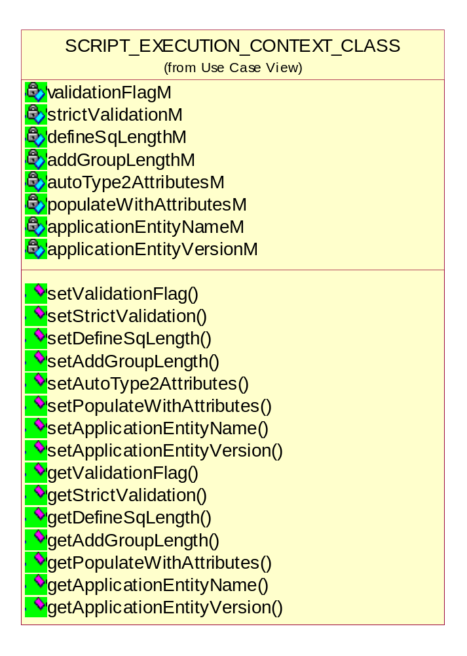
Figure 9 Class diagram of Script execution context

Setting/Getting the Validation flag
void setValidationFlag(VALIDATION_CONTROL_FLAG_ENUM);
VALIDATION_CONTROL_FLAG_ENUM getValidationFlag();
In this method, the validation option is set. Depending on the value of validation control flag, the validation against definition, VR or referenced object

Setting/Getting the StrictValidation flag
void setStrictValidation(bool);
bool getStrictValidation();
In this method, the strict validation option is set.

Setting/Getting the Define SQ Length flag
void setDefineSqLength(bool);
bool getDefineSqLength();

Setting/Getting the Add Group Length flag
void setAddGroupLength(bool);
bool getAddGroupLength();

Setting/Getting the Auto Type 2 Attributes flag
void setAutoType2Attributes(bool);
In this method, the AutoType2Attributes option is set.

Setting/Getting the Populate With Attributes flag
void setPopulateWithAttributes(bool);
bool getPopulateWithAttributes();
In this method, the populate with attributes option is set. The return value depends on whether the populateWithAttributes is true or not, if true return the session value defined by autoType2Attributesand if false it returns false.

Setting/Getting the Application Entity Name
void setApplicationEntityName(string);
string getApplicationEntityName();

Setting/Getting the Application Entity Version
void setApplicationEntityVersion(string);
string getApplicationEntityVersion();

BNF Grammar for the Session File Parameters
The following section defines that BNF Grammar for parsing the Session File parameters.

Language : /* empty */
| LanguageGrammar
;

LanguageGrammar : LanguageComponents
| LanguageGrammar LanguageComponents
;

LanguageComponents : Session
;

Session : BeginSession SessionContentList EndSession
;

BeginSession : T_SESSION
;

EndSession : T_ENDSESSION
;

SessionContentList : SessionContent
| SessionContentList SessionContent
;

SessionContent : T_SESSION_FILE_VERSION INTEGER
| T_SESSION_TYPE SESSION_TYPE
| T_SESSION_TITLE STRING
| T_SESSION_ID INTEGER
| T_MANUFACT STRING
| T_MODEL STRING
| T_SOFTWARE STRING
| T_APPL_ENTITY_NAME STRING
| T_APPL_ENTITY_VERSION STRING
| T_TESTED STRING
| T_DATE STRING
| T_PRODUCT_ROLE_ACCEPTOR TRUE_OR_FALSE
| T_PRODUCT_ROLE_REQUESTOR TRUE_OR_FALSE
| T_CALLED_AE STRING
| T_CALLING_AE STRING
| T_MAX_LEN INTEGER
| T_IMPL_CLASS STRING
| T_IMPL_VER STRING
| T_REMOTE_HOST_NAME STRING
| T_PORT INTEGER
| T_REMOTE_PORT INTEGER
| T_LOCAL_PORT INTEGER
| T_SOCKET_TIMEOUT INTEGER
| T_SUT_AE STRING
| T_SUT_MAX_LEN INTEGER
| T_SUT_IMPL_CLASS STRING
| T_SUT_IMPL_VER STRING
| T_SUT_HOSTNAME STRING
| T_SUT_PORT INTEGER
| T_SUT_ROLE SUT_ROLE
| T_DVT_AE STRING
| T_DVT_MAX_LEN INTEGER
| T_DVT_IMPL_CLASS STRING
| T_DVT_IMPL_VER STRING
| T_DVT_PORT INTEGER
|T_DVT_SOCKET_TIMEOUT INTEGER
| T_USE_SECURE_SOCKETS TRUE_OR_FALSE
| T_TLS_VERSION STRING
| T_CHECK_REMOTE_CERTIFICATE TRUE_OR_FALSE
| T_CIPHER_LIST STRING
| T_CACHE_TLS_SESSIONS TRUE_OR_FALSE
| T_TLS_CACHE_TIMEOUT INTEGER
| T_CREDENTIALS_FILENAME STRING
| T_CERTIFICATE_FILENAME STRING
| T_VAL_RES TRUE_OR_FALSE
| T_DIMSE_MSG TRUE_OR_FALSE
| T_ACSE_MSG TRUE_OR_FALSE
| T_PDU_DUMP TRUE_OR_FALSE
| T_LABEL_DUMP TRUE_OR_FALSE
| T_IMAGE_SAVE TRUE_OR_FALSE
| T_DEF_SQ_LENGTH TRUE_OR_FALSE
| T_ADD_GROUP_LENGTH TRUE_OR_FALSE
| T_CONTINUE TRUE_OR_FALSE
| T_SUPPORTED_TRANSFER_SYNTAX STRING
| T_FORMAT TRUE_OR_FALSE
| T_STORAGE_MODE STORAGE_MODE
| T_STRICT TRUE_OR_FALSE
| T_DETAILED_RESULTS TRUE_OR_FALSE
| T_SUMMARY_RESULTS TRUE_OR_FALSE
| T_INCLUDE_TYPE3_NOTPRESENT TRUE_OR_FALSE
| T_AUTO_TYPE TRUE_OR_FALSE
| T_AUTO_CREATE TRUE_OR_FALSE
| T_LOG_ERROR TRUE_OR_FALSE
| T_LOG_WARNING TRUE_OR_FALSE
| T_LOG_INFO TRUE_OR_FALSE
| T_LOG_RELATION TRUE_OR_FALSE
| T_LOG_DEBUG TRUE_OR_FALSE
| T_LOG_DICOM LOG_LEVEL
| T_DICOM_VAL_RES LOG_LEVEL
| T_LOG_ACSE LOG_LEVEL
| T_LOG_SCP_THREAD TRUE_OR_FALSE
| T_DULP_STATE TRUE_OR_FALSE
| T_ACSE_VAL_RES LOG_LEVEL
| T_DEFINITION_DIRECTORY STRING
| T_DEFINITION_ROOT STRING
| T_DEFINITION STRING
| T_DICOMSCRIPT_ROOT STRING
| T_DICOMSCRIPT STRING
| T_RESULTS_ROOT STRING
| T_DESCRIPTION_DIRECTORY STRING
| T_APPEND_TO_FILE TRUE_OR_FALSE
| T_INCLUDE_PATH STRING
;

The BNF tokens are:

SESSION T_SESSION
ENDSESSION T_ENDSESSION
SESSION-FILE-VERSION T_SESSION_FILE_VERSION
SESSION-TYPE T_SESSION_TYPE
SESSION-TITLE T_SESSION_TITLE
SESSION-ID T_SESSION_ID
MANUFACTURER T_MANUFACT
MODEL-NAME T_MODEL
APPLICATION-ENTITY-NAME T_APPL_ENTITY_NAME
APPLICATION-ENTITY-VERSION T_APPL_ENTITY_VERSION
SOFTWARE-VERSIONS T_SOFTWARE
TESTED-BY T_TESTED
DATE T_DATE
PRODUCT-ROLE-IS-SCP T_PRODUCT_ROLE_ACCEPTOR
PRODUCT-ROLE-IS-ACCEPTOR T_PRODUCT_ROLE_ACCEPTOR
PRODUCT-ROLE-IS-SCU T_PRODUCT_ROLE_REQUESTOR
PRODUCT-ROLE-IS-REQUESTOR T_PRODUCT_ROLE_REQUESTOR
CALLED-AE-TITLE T_CALLED_AE
CALLING-AE-TITLE T_CALLING_AE
MAXIMUM-LENGTH-RECEIVED T_MAX_LEN
IMPLEMENTATION-CLASS-UID T_IMPL_CLASS
IMPLEMENTATION-VERSION-NAME T_IMPL_VER

SUT-AE-TITLE T_SUT_AE
SUT-MAXIMUM-LENGTH-RECEIVED T_SUT_MAX_LEN
SUT-IMPLEMENTATION-CLASS-UID T_SUT_IMPL_CLASS
SUT-IMPLEMENTATION-VERSION-NAME T_SUT_IMPL_VER
SUT-HOSTNAME T_SUT_HOSTNAME
SUT-PORT T_SUT_PORT
SUT-ROLE T_SUT_ROLE

DVT-AE-TITLE T_DVT_AE
DVT-MAXIMUM-LENGTH-RECEIVED T_DVT_MAX_LEN
DVT-IMPLEMENTATION-CLASS-UID T_DVT_IMPL_CLASS
DVT-IMPLEMENTATION-VERSION-NAME T_DVT_IMPL_VER
DVT-PORT T_DVT_PORT
DVT-SOCKET-TIMEOUT T_DVT_SOCKET_TIMEOUT

SCP-HOST-NAME T_REMOTE_HOST_NAME
REMOTE-HOST-NAME T_REMOTE_HOST_NAME
TCP-IP-PORT T_PORT
REMOTE-CONNECT-PORT T_REMOTE_PORT
LOCAL-LISTEN-PORT T_LOCAL_PORT
SOCKET-TIMEOUT T_SOCKET_TIMEOUT
USE-SECURE-SOCKETS T_USE_SECURE_SOCKETS
TLS-VERSION T_TLS_VERSION
CHECK-REMOTE-CERTIFICATE T_CHECK_REMOTE_CERTIFICATE
CIPHER-LIST T_CIPHER_LIST
CACHE-TLS-SESSIONS T_CACHE_TLS_SESSIONS
TLS-CACHE-TIMEOUT T_TLS_CACHE_TIMEOUT
CREDENTIALS-FILENAME T_CREDENTIALS_FILENAME
CERTIFICATE-FILENAME T_CERTIFICATE_FILENAME

VALIDATION-RESULTS T_VAL_RES
DIMSE-MESSAGES T_DIMSE_MSG
ACSE-MESSAGES T_ACSE_MSG
PDU-DUMP T_PDU_DUMP
LABEL-DUMP T_LABEL_DUMP
SAVE-IMAGE-DATA T_IMAGE_SAVE
DEFINE-SQ-LENGTH T_DEF_SQ_LENGTH
ADD-GROUP-LENGTH T_ADD_GROUP_LENGTH
CONTINUE-ON-ERROR T_CONTINUE
SCP-EMULATOR-TS T_SUPPORTED_TRANSFER_SYNTAX
SUPPORTED-TRANSFER-SYNTAX T_SUPPORTED_TRANSFER_SYNTAX
FORMAT-IS-MEDIA T_FORMAT
STRICT-VALIDATION T_STRICT
DETAILED-VALIDATION-RESULTS T_DETAILED_RESULTS
SUMMARY-VALIDATION-RESULTS T_SUMMARY_RESULTS
INCLUDE-TYPE-3-NOTPRESENT-INRESULTS T_INCLUDE_TYPE3_NOTPRESENT
AUTO-TYPE-2-ATTRIBUTES T_AUTO_TYPE
AUTO-CREATE-DIRECTORY T_AUTO_CREATE
LOG-ERROR T_LOG_ERROR
LOG-WARNING T_LOG_WARNING
LOG-INFO T_LOG_INFO
LOG-RELATION T_LOG_RELATION
LOG-DEBUG T_LOG_DEBUG
LOG-DICOM-MESSAGES T_LOG_DICOM
LOG-DICOM-VALIDATION-RESULTS T_DICOM_VAL_RES
LOG-ACSE-MESSAGES T_LOG_ACSE
LOG-ACSE-VALIDATION-RESULTS T_ACSE_VAL_RES
LOG-DULP-STATE T_DULP_STATE
LOG-SCP-THREAD T_LOG_SCP_THREAD
STORAGE-MODE T_STORAGE_MODE
DEFINITION-DIRECTORY T_DEFINITION_DIRECTORY
DEFINITION-ROOT T_DEFINITION_ROOT
DEFINITION T_DEFINITION
DICOMSCRIPT-ROOT T_DICOMSCRIPT_ROOT
DICOMSCRIPT T_DICOMSCRIPT
RESULTS-ROOT T_RESULTS_ROOT
DESCRIPTION-DIRECTORY T_DESCRIPTION_DIRECTORY
APPEND-TO-RESULTS-FILE T_APPEND_TO_FILE
INCLUDE-PATH T_INCLUDE_PATH

true trueOrFalse = true TRUE_OR_FALSE
false trueOrFalse = false TRUE_OR_FALSE
none LOG_LEVEL
raw LOG_LEVEL
standard LOG_LEVEL
short LOG_LEVEL
long LOG_LEVEL
tabular LOG_LEVEL
script sessionType = ST_SCRIPT SESSION_TYPE
emulator sessionType = ST_EMULATOR SESSION_TYPE
media sessionType = ST_MEDIA SESSION_TYPE
no-storage storageMode = SM_NO_STORAGE STORAGE_MODE
as-dataset storageMode = SM_AS_DATASET STORAGE_MODE
as-media storageMode = SM_AS_MEDIA STORAGE_MODE
acceptorAndRequestor sutRole = UP_ACCEPTOR_REQUESTOR SUT_ROLE
acceptor sutRole = UP_ACCEPTOR SUT_ROLE
requestor sutRole = UP_REQUESTOR SUT_ROLE

INTEGER
STRING

Some of the above tokens were used in earlier versions of DVT and are present to allow DVT 2.1 to parse older session files. These tokens will not be used when the session file is serialized (written) – only tokens valid for DVT 2.1 will be used.

